 | Oil & Gas Development Company Ltd.  Location: ______________________________  VEHICLE INSPECTION CHECKLIST | OGC/TPT-002(00)
TPT Section |  | Monitoring Frequency:  Daily (Physical Inspection)/ Annual (Fitness Check)
L
G
A
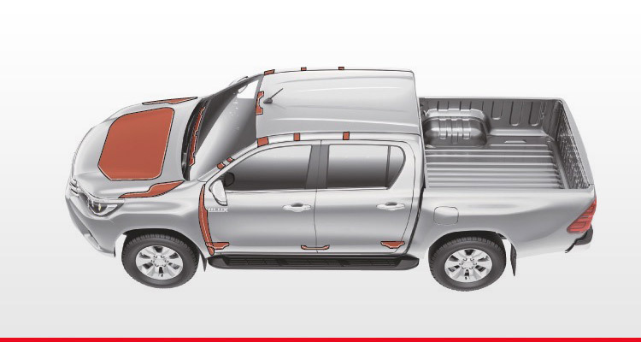
L
K
J
I
H
F
E
D
C
B
Sr. | Checkpoint |  | Condition
 |  |  | Good | Fair | Defective
 | Steering | A
 | Antilock Breaking System / Foot Paddle / Handbrake
 | Air Bags (esp. at driver’s end)
 | Parking / Headlights | B
 | Hazards & Indicator Lights | C
 | Horn
 | Windscreen / Washers / Wipers | D
 | Shock Absorbers | E
 | Suspension
 | Speedometer / RPM Meter
 | Battery (Connectors Greased / Clamped / Properly Fixed / No Rust)
 | Visual General Wiring Codition
 | Spare Fuses (Available)
 | Brake / Rear Lights & Hi / Low Beams | F
 | Cabin Light
 | Electric Cables & Wiring
 | Starting Performance
 | Fluid Level
 | Exhaust Manifold & Silencer Condition (Leaks / Hole / Loose Fitting)
 | Visual Hoses / Belt & Pipe Condition
 | Visual Radiator Condition
 | Air Condition & Heating System
 | Gears Conditions
 | Selt Belts
 | Central Locking Sysetm
 | Body’s Visual Condition | G
 | Engine’s Apparent Condition | H
 | Doors / Lock / Handle Condition | I
 | Tyres / Spare Tyre Condition | J
 | Wheel Aligment | K
 | Under-run Protection; Rollover Protection Devices | L
 | Head Restraints
 | Reversing alarm system (for heavy vehicles)
Remarks:________________________________________________________________________________________________________________________________________________________________________________________________________________________________________________________________________________________________________________________________________________________________________________________________________________________________________
Inititated by |  | Reviewed by |  | Verified/ Approved by
Daily: Driver  Yearly: Maint. Rep. |  | Daily: TPT Rep.  Yearly: InCharge TPT |  | Daily: TPT Rep.  Yearly: InCharge Maint.

